RESUMEN

filter1 = df['Country'].isin(['Colombia','Brazi'])

df2 = df[filter1]

filter1 = df['bath']>3

df2 = df[filter1]

df2

df.query('bath > 3 & price>100')

df.query('Salary_in_1000 >= 100 & Age < 60 & FT_Team.str.startswith("S").values')

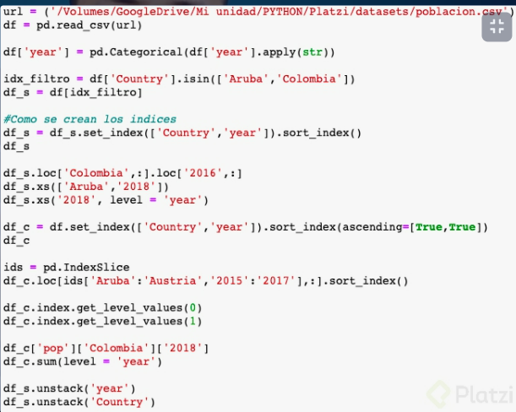

#todas las finas, y las primeras 6 columnas

df.iloc[:,6]

idx_filtro_country = df_pob['Country'].isin(['Aruba','Colombia','Austria','Andorra'])

idx_filtro_pop = df_pob['pop'].le(1000000)

idx_filtro_year = df_pob['year'].isin(['2015','2016'])

idx_filtro_total = idx_filtro_country*idx_filtro_pop*idx_filtro_year

idx_filtro_total

#cargue y no tome en cuenta las primeras 4 lines

df_pob = pd.read_csv('poblacion.csv', skiprows=4)

df_pob

#Cambie de notacion cientifica a float

pd.options.display.float_format='{:,.lf}format

#Cambie a String

df['year']=pd.Categorical(df['year'].apply(str))

**#casilla pob a numerico**

df_pob['pob'] = pd.to_numeric(df_pob['pob'])

idx_filtro = df['Country'].isin(['Aruba','Colombia'])

idx_filtro

<nos dara true, false, segun esta>

**#Para tener esos paises y sort**

df = df[idx_filtro]

df = df.set_index(['Contry','year']).sort_index()

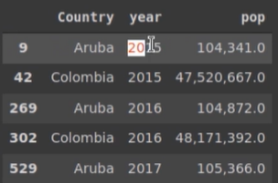

df.loc['Colombia',:]

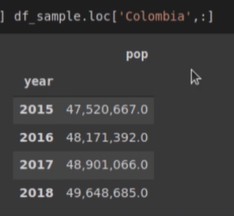

df.loc['Colombia',:].loc['2016',:]



df.xs(['Aruba'])

df.xs(['Aruba','2018'])

df.xs('2018',level='year')

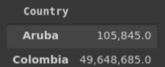

df.set_index(['Country','year']).sort_index(ascending=[False,True])

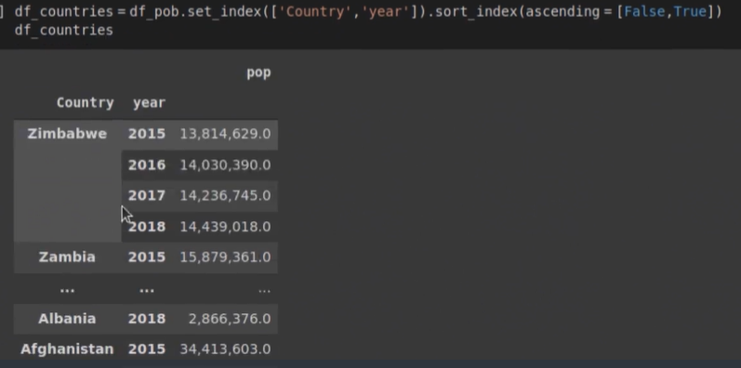

ids = pd.IndexSlice

df.loc[ids['Aruba':'Austria','2015':'2017'],:].sort_index()

df.set_index([‘Country’,’year’]).sort_index(ascending-[False,True])

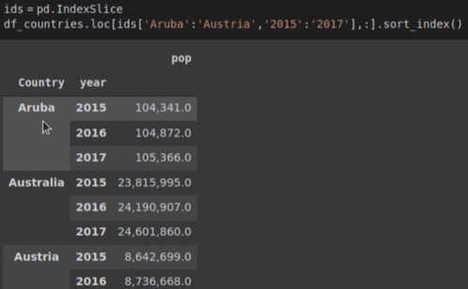



df.sum(level='year')

Equivalente a

select year, sum(pop) from table group by year

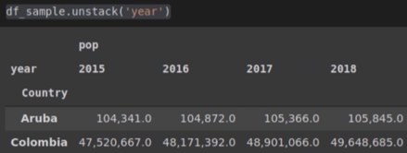

df_pob['Colombia','2018']

Filtro Si contiene 'or'

df['names'].str.contains('or')

names

0 True

1 False

2 False

3 False

4 True

5 False

= = = = =

#Registros que condicion es 'female' y 'Survice'

# Sex = femane / male Survive 0,1

df2 = df.loc[df.Sex=='female']['Survived']

Nos daria

0

1

0

1

1

0

#Promedio de mujeres que sobrevivieron

# suma de '1' nos da las que sobrevivieron, y len es el total de registros

df2 = sum(df2)/len(df2)

#En nuevo campo poner 'No_survived' o "Survived' segun valor para categorizar

df['name']= df['Survived'].map({0:'No_survived', 1:'survived'})